Lab 2: Writing a Basic Client

1. Introduction
Proof of Work (PoW) is a computational process that is used to ensure that a certain amount of work is done before a task is allowed to proceed within a system. It is used by many distributed systems and cryptocurrencies to prevent spam and denial of service attacks. The main idea behind PoW is that the work should be hard to do and simple to verify.
In a PoW system, a client is expected to solve a cryptographic puzzle by finding a certain piece of information referred to as a nonce. The nonce is combined with a predetermined string and run through a cryptographic hash function such as SHA-256. The main aim is to find a hash that starts with a certain number of zeros. The number of zeros defines the level of difficulty within the puzzle. As the level of difficulty rises, the amount of work done exponentially rises while the verification process remains almost instantaneous.
In blockchain systems, Proof of Work is used as a consensus algorithm to protect the integrity of the network by making it costly for an individual to attempt to manipulate the data within the network. Therefore, by ensuring a certain level of computational power, Proof of Work promotes fairness and prevents abuse in a decentralized system.
In this laboratory exercise, a simplified version of a Proof of Work client program is to be written, enabling it to communicate with a server program via a TCP socket. A challenge message and a corresponding difficulty level are sent from the server, and the client has to compute a valid nonce and send it back to the server along with the student ID.
In this experiment, a computational puzzle is being presented as a method of security, and a hands-on approach to cryptographic hashing, TCP socket programming, and brute-force attacks is being introduced.
2. Implementation
1. Establishing the TCP Connection

To begin with, a TCP socket connection was established between the client and the server.
The client used the SERVER_HOST and SERVER_PORT constants to establish the connection.
The client used Python's socket library to establish the connection.

A socket object was created by passing the following parameters to the socket() function:
socket.AF_INET - It is used for IPv4 addressing.
socket.SOCK_STREAM - It is used for TCP communication.
After creating the socket object, the client connected to the server by:client.connect((SERVER_HOST, SERVER_PORT))
This step enabled reliable, connection-oriented communication between the client and the Proof-of-Work server.

2.Receiving the Challenge and Difficulty

The client waited for a message from the server after a successful connection.

The server sent a message with a string in the following format:

challenge_string difficulty_value

For example, the string would be:

abc123xyz 4

The string received by the client is decoded from bytes into a string and stripped of trailing whitespace characters.
The string is then split into two parts using the split() method, and the string is divided into two parts:
prefix → The string that is the challenge
difficulty → The number of zeros needed at the front of the SHA-256 hash code

3. Performing the Proof of Work (Nonce Search)

The main part of the code is the computation of the Proof of Work.

The target string with the required number of zeros was created first:

target = "0" * difficulty

For example, if the value of difficulty is 4, the target string would be "0000".

Next, the brute force search process was initiated.

The value of the nonce was set to 0.

The process was continued by repeating the following steps until the solution was found:

The client combined the challenge string and the current value of the nonce:

data = prefix + str(nonce)

The SHA-256 hash value of the combined string was calculated:

hash_result = hashlib.sha256(data.encode()).hexdigest()

The hexadecimal output of the hash function was checked to see if the hash result starts with the required number of zeros:

hash_result.startswith(target)

If the condition is satisfied, the current value of the nonce is valid.
The process stops.
The process continues by increasing the current value of the nonce by 1.
The brute force search process is an example of the Proof of Work process, which is computationally expensive to perform but easy to verify.

4.Sending the Solution to the Server

After finding the valid nonce, the client sent the solution back to the server in the appropriate format. The format is as follows:

student_number nonce

For instance:

2020123456 48291

The message is encoded into bytes and sent via the following code:

client.sendall(message.encode())

5. Receiving the Server Response

Finally, the client received the response sent by the server.

The server sends the response in the following format:

OK

SUCCESS

FAIL

The client received the response, decoded it, and then printed it. After that, the client terminated the communication by closing the socket.

Conceptual Summary

This code shows an example of the Proof of Work protocol. The code is simplified. The main elements are as follows:

The server determines the difficulty.

The client performs brute-force search.

The solution is verified by checking the constraints of the hash.

Communication is done via TCP sockets.

The difficulty level is directly proportional to the computational effort.
3. Code Explanation
3.1 Overall Program Flow
The program is a simple Proof of Work (PoW) client that connects to a remote server via a TCP socket. Once connected, it receives a one-line message from the server that contains a challenge_string (prefix), and a difficulty value. The client then calculates a valid nonce via brute force so that the SHA256 hash of (prefix + nonce) has a specified number of leading zeros. The client then sends a response back to the server that contains the student number and the valid nonce, and prints the response from the server.

3.2 Libraries Used

socket: This library is used to establish the TCP client and interact with the server.

hashlib: This library is used to obtain the SHA-256 hash values in hexadecimal format.

3.3 Constant Parameters

The constants below are defined for the server endpoint and the student ID:

SERVER_HOST: The IP address of the server

SERVER_PORT: The port number of the server

STUDENT_NO: The student ID sent along with the nonce value to the server
3.4 Function: find_nonce(prefix, difficulty)

Purpose:
The purpose of the find_nonce function is to find a valid nonce that meets the PoW condition set by the server.

Input arguments:

prefix: The prefix string sent by the server.

difficulty: The number of zeros that should be present at the beginning of the SHA-256 hash output (in hexadecimal).

How it works (step by step):

Target creation:
The function begins by creating a target string with the required number of zeros:

target = "0" * difficulty
For example, if difficulty is 4, then target will be "0000".

Brute force search:
The nonce is initialized with a value of 0, and we keep increasing it until we find a valid nonce:

Create a data string: data = prefix + str(nonce)

hash_result = hashlib.sha256(data.encode()).hexdigest()

Validate: hash_result.startswith(target)

Return value:
The function returns the valid nonce when a valid hash result is found.

Why it is called Proof-of-Work:
The process requires a large number of hash attempts, which is computationally expensive. However, it is very quick and simple to validate a hash result, which requires only a single SHA-256 hash calculation and a prefix check.

3.5 Function: main()

The main() function is responsible for networking and computing.

Steps involved in main() function:

Create a socket:
The socket is initialized with IPv4 and TCP (AF_INET, SOCK_STREAM).

Connect to the server:
The client connects to (SERVER_HOST, SERVER_PORT).

Receive server message:
The client receives a line from the server containing:

prefix
difficulty
The line is decoded into a string, stripped, and then split into two parts with split().

Compute a valid nonce:
find_nonce(prefix, difficulty) is invoked.

Send solution:
The client sends a line with the following format:

"student_number nonce"

Receive server response and close socket:
The server’s response (OK, FAIL, SUCCESS, etc.) is received, printed, and then the socket is closed correctly.

3.6 Output and Verification

The program prints the following when run:

The prefix and difficulty received from the server.

The computed valid nonce.

The response message from the server.
4. Results
The Proof of Work client program was run successfully and established a TCP connection with the server at the designated IP address and port number.

After establishing the connection with the server, the server sent a challenge string and a difficulty value to the client. During this test case, the server sent the following values to the client:

The challenge string (prefix): trJnVeZN
The difficulty value: 3

This indicates that the client had to find a nonce value that would satisfy the condition that the SHA-256 hash of the string formed by appending the nonce to the challenge string would have three leading zeros.

The client used a brute force approach to find the nonce value and was successful in finding the nonce value.

The nonce value: 6037

The client sent the student number along with the calculated nonce value to the server in the required format: student_number nonce

The server responded with the following message after receiving the student number and the calculated nonce value from the client:

The server response: OK

The terminal output shows the received challenge string from the server, the difficulty value received from the server, the calculated nonce value by the client, and the server's response to the client.

5. Answers to Questions

Q1:
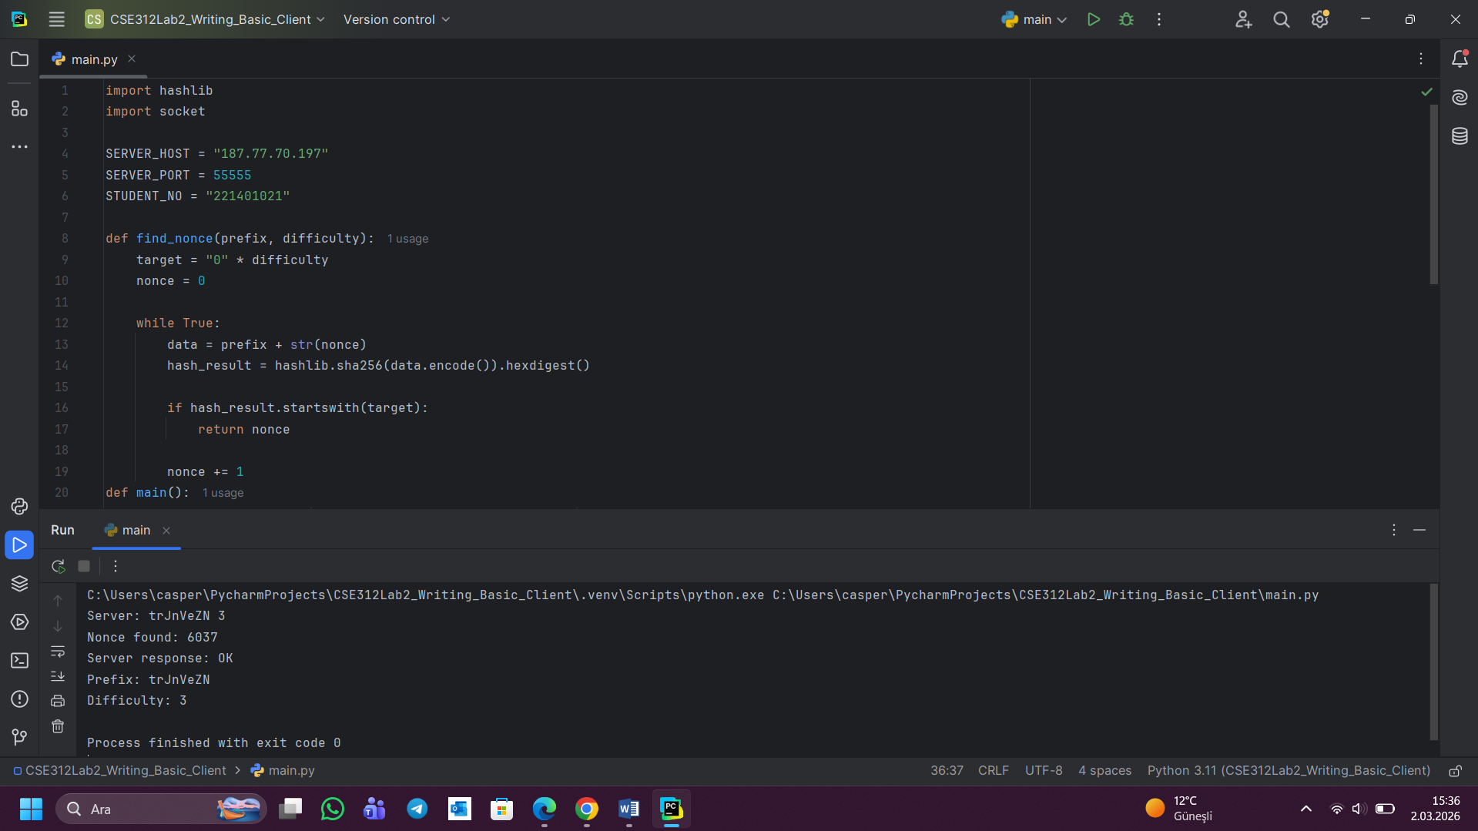
Q2:
In the context of cryptocurrencies, the concept of "Proof of Work" (PoW) requires a participant to complete a certain level of work before they are permitted to finish a given task. However, the underlying concept of PoW is to ensure that the process of generating a solution to a problem requires a large amount of work, but at the same time, the process of verifying the correctness of the solution should be simple and quick. In the context of a PoW system, a client needs to find a nonce value such that when the nonce value is combined with a given challenge string and a cryptographic function like SHA-256 is used to hash the combined value, the resulting hash meets a given condition. In this lab, the condition that needs to be met for the hash value is that it needs to begin with a specified number of leading zeros. This number of leading zeros determines the difficulty level of the task. In the case of SHA-256, the output hash value can be considered a random number, and the probability that the hash value begins with a single zero is 1/16, considering it a hexadecimal value. If the hash value needs to begin with two leading zeros, then the probability would be (1/16)^2, and if the difficulty level is ‘d,’ then the probability would be (1/16)^d. This exponential growth means that increasing the difficulty greatly increases the computational work required to find a valid nonce, although verification is still easy, as the server simply has to perform a single hash function and check to see if it starts with the required number of zeros. This is the basic idea behind all Proof of Work systems.

Q3:
The find_nonce function is used to find a nonce value that fulfills the Proof of Work requirement provided by the server. It takes a challenge string represented by the prefix and a difficulty value as input parameters. First, a target string is created by adding the required number of zeros to the string. If the difficulty is 2, the target will be "00." Next, the function starts checking from nonce = 0 by appending the prefix and the current nonce value, followed by computing the SHA-256 hash of this new string and checking if the hash starts with the target string. If this condition is true, the function returns the nonce value; otherwise, the nonce value is incremented and the process continues until the condition is satisfied. For example, if the challenge is "abc123" and the difficulty is 2, the function checks values like "abc1230," "abc1231," and so on until the hash starts with "00," at which point this nonce value is returned by the function.

Q4:
One real-world example of the use of Proof of Work is Bitcoin. Bitcoin works by requiring miners to perform a computational task by finding a number that makes the hash of a block of Bitcoin transactions start with a certain number of zeros. This makes it computationally expensive to add new blocks to the blockchain. Proof of Work is needed for Bitcoin because it helps prevent malicious actors from manipulating the transaction history of Bitcoin. If someone wants to alter the blockchain, they would need to redo the computational work of all the blocks before the one they want to alter, which would take enormous computational power.

One of the main benefits of Proof of Work is that it provides security and helps prevent malicious actors from attacking decentralized systems by preventing double spending. However, one of the main drawbacks of Proof of Work is that it uses a lot of energy. It takes a lot of computational power to perform the work needed to mine Bitcoin, which means that there is a high energy cost associated with this process.

Q5:
If the difficulty level is increased dynamically based on the load on the server, the client would be forced to compute more hash operations for finding a valid nonce value. As the probability of finding a valid hash value decreases exponentially with the increase in difficulty, the time required for processing would be increased for the client. This could result in a slower system.

The advantages that can be derived from this scheme are that the server can be protected from overload, spam, or denial-of-service attacks. When the server load is high, the difficulty level can be increased, which would require the client to spend more time computing before sending requests. However, the disadvantage that can be derived from this scheme is that users can also be impacted. Users with lower computational devices would find it difficult to find the valid nonce value within a reasonable time.

